🛠️ Format Guide for the Toolkit Document

1. Title & Objective
- Getting Started with C programming – A Beginner’s Guide
- I choose C programming
- I choose C programming because it’s the first language I learned so far in my syllabus in school.
- My end goal is to create a working Weather app with C programming.

2. Quick Summary of the Technology
- C programming is general purpose programming language
- C is a general purpose programming language created in 1972 by Dennis Ritchie.
- It is fast and efficient
- Used for system programming
- It is the foundation of many other languages
- One real-world example is : ATM Machine software

3. System Requirements

✅ Operating System (OS)
C works on all major operating systems:
- Windows
- Linux
- macOS

🛠️ Tools / Editors Required

1. C Compiler (Required)
A compiler converts C code into machine code.
- Windows
  - MinGW (GCC for Windows)
  - MSYS2
- Linux
  - GCC (usually pre-installed)
- macOS
  - Xcode Command Line Tools (includes GCC/Clang)
👉 Check compiler:
gcc --version

2. Code Editor / IDE (Recommended)
You can write C code in any text editor, but these are popular:
- VS Code (Recommended)
- Code::Blocks
- Dev-C++
- Sublime Text
- Atom
- Code::Blocks::
- C/C++ (by Microsoft)
- Code Runner

📦 Packages / Libraries
- ❌ No package manager required (unlike npm or pip)
- ✅ Standard C libraries come with the compiler:
  - stdio.h
  - stdlib.h
  - string.h
  - math.h

4. Installation & Setup Instructions
- How to download code block steps :
- Go to Google and type Code Block download

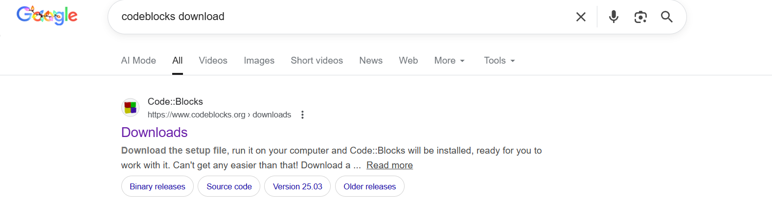
- Then click on the the above and it will take you to :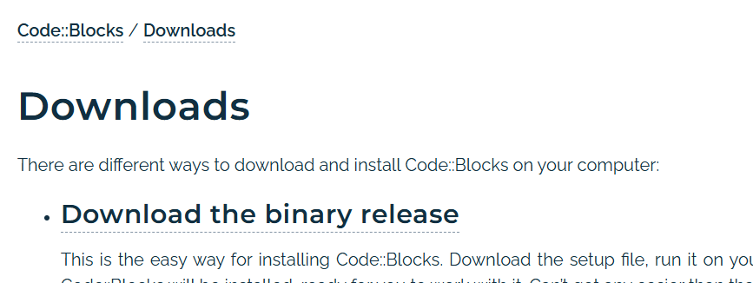

- Click on Download the binary release and the next step is :

- Then click on codeblocks – 25.o3mingw – setup.exe Sourceforge.net shown above
- Then it will start Setup loading :
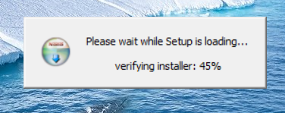

- Then click next and continue the process :
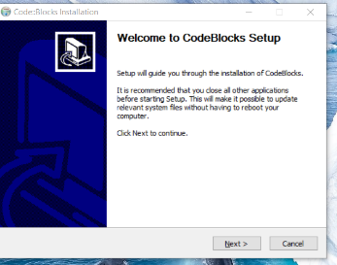
- Choose “I agree” :
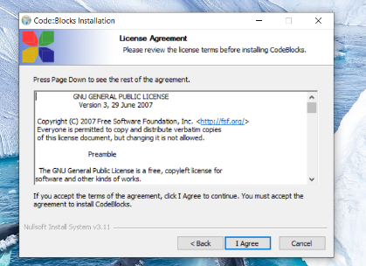

- Click Next :
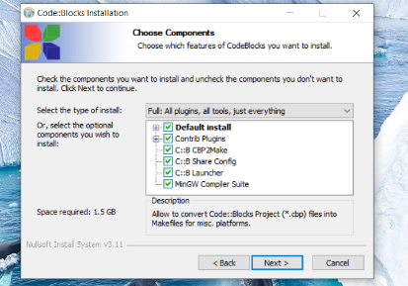

- Click Install :
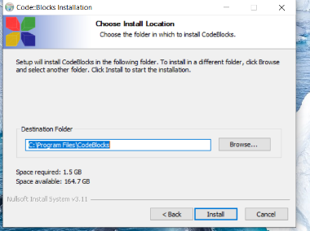

- Code block is then downloaded it looks as shown below:
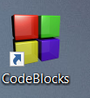

5. Minimal Working Example

Description
This minimal working example demonstrates a basic C program that outputs a message to the console.
The purpose of this example is to verify that the C compiler and Code::Blocks environment are correctly installed and functioning.
The program uses standard input/output functions provided by the C standard library.
- Source code :
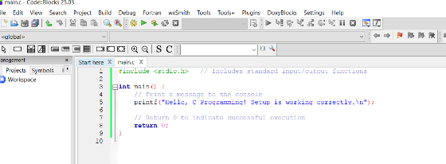

Code explanation :
- #include <stdio.h>
Imports the Standard Input Output library required for printf().
- int main()
Entry point of the C program where execution begins.
- printf()
Outputs the specified text to the console.
- return 0;
Terminates the program successfully.
- Expected output :
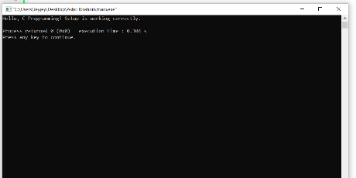

- Outcome :
- If the above output is displayed, it confirms that :
- Code::block is properly installed
- The GCC compiler is correctly configured
- The system is ready for further C program development

6. AI Prompt Journal
- Prompt 1 : Give me a step-by-step guide to initialize C programming :
- Goal : Need to set up C programming environment and understand the basics to start learning.
- A.I Summary Response :
(1) Installing a C compiler (GCC/Clang for Mac/Linux, MinGW for Windows)
(2) Setting up a code editor or IDE (VS Code, Code::Blocks)
(3) Writing a basic "Hello World" program with proper syntax
(4) Compiling the program using gcc command in terminal
(5) Running the compiled executable
(6) Troubleshooting common setup issues. The response included actual code examples and terminal commands.
• What worked well: Clear step-by-step instructions, troubleshooting help was specific to my error message.
• What could be improved: Could have asked about my operating system first for more tailored instructions.

- Outcome: Successfully compiled and ran my first C program. Development environment is now fully set up.

Prompting Tips Learned
- Tip 1: Be specific about your context (OS, experience level)
- Tip 2: Ask for step-by-step instructions when learning new processes

7. Common Issues & Fixes
- Forgetting semi- colons while coding causes errors.
- I would solve the errors by adding semi-colons to my code block.
- Use comments to understand your code well and to make it efficient.

8. References
- Microsoft C/C++ Documentation
- URL: https://learn.microsoft.com/en-us/cpp/c-language/
- Description: C language reference for Microsoft C/C++ compiler
- Best for: Windows development and Visual Studio users
- C Standard Library Reference
- URL: https://en.cppreference.com/w/c
- Description: Complete standard library documentation with examples
- Best for: Learning standard functions (stdio.h, stdlib.h, string.h, etc.)
- Video Links
freeCodeCamp.org
- Channel: https://www.youtube.com/c/Freecodecamp
- Best Video: "C Programming Tutorial for Beginners" (4 hours comprehensive course)
- Why: Highly acclaimed for extensive quality educational content, perfect starting point
- Level: Complete beginners
Bro Code
- Channel: https://www.youtube.com/@BroCodez
- Description: Beginner-friendly with clear explanations and practical approach
- Coverage: Basic syntax, loops, arrays, functions with real-world examples
- Level: Beginners
- Helpful blog post
• GeeksforGeeks - C Programming
- URL: https://www.geeksforgeeks.org/c-programming-language/
- Description: Well-written articles, quizzes, practice problems
- Best for: Concept explanations with examples
- Topics: All C concepts from basics to advanced
Tutorials point - C Programming
- URL: https://www.tutorialspoint.com/cprogramming/
- Description: Comprehensive tutorials with examples
- Best for: Step-by-step learning with clear examples
- Topics: Complete C language coverage

